**NA PROJECT - REPORT  
 Anirudh Tallavajhula-16354364**

**Network Calculator Application**

**Technical Implementation Report**

# Executive Summary

This report documents the implementation of a network-based calculator application using Node.js, Express, and Socket.IO. The application demonstrates real-time communication between client and server and performs basic mathematical operations through a web interface.

# 1. Project Setup and Environment Configuration

## 1.1 Initial Project Creation

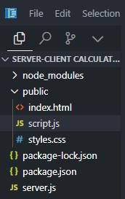

The project initialization began with creating a dedicated directory structure.

## 1.2 Node.js Project Initialization

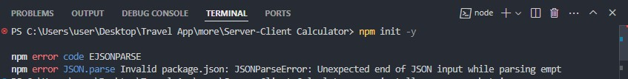

The Node.js project was initialized using npm . The command npm init -y created our package.json file with default values, providing the foundation for our dependency management and script configuration.

## 1.3 Dependency Installation

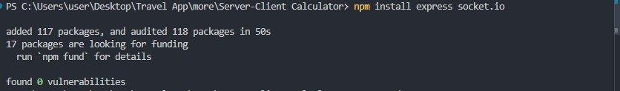

Essential dependencies were installed using npm:

1. Express.js: Web application framework
2. Socket.IO: Real-time bidirectional communication library
3. Nodemon: Development dependency for automatic server reloading

# 2. Application Architecture and Implementation

## 2.1 Server-Side Implementation

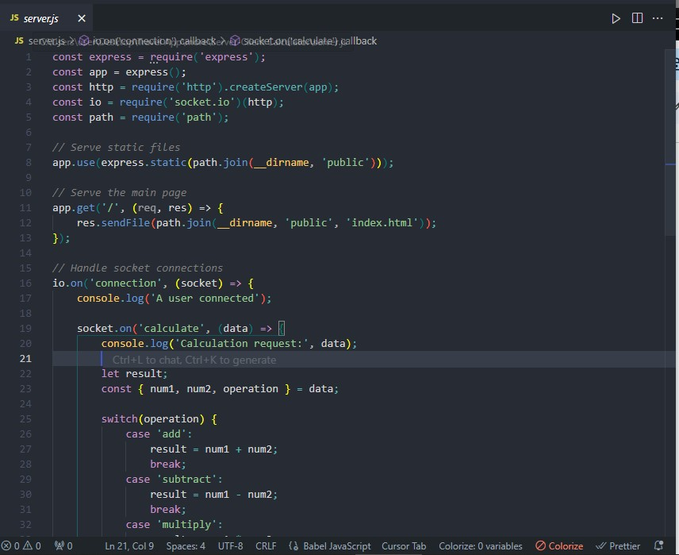 The server implementation consists of three main components:

1. Express server setup for serving static files
2. Socket.IO integration for real-time communication
3. Mathematical operation handling

Key features implemented in the server include:

1. HTTP server creation using Express
2. Socket event handling for calculations
3. Error handling for invalid operations
4. Support for multiple concurrent connection

## 2.2 Project Structure Organization

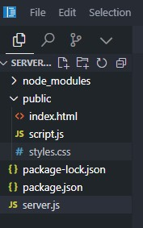

The project follows a clean, modular structure:

## 2.3 Client-Side Implementation

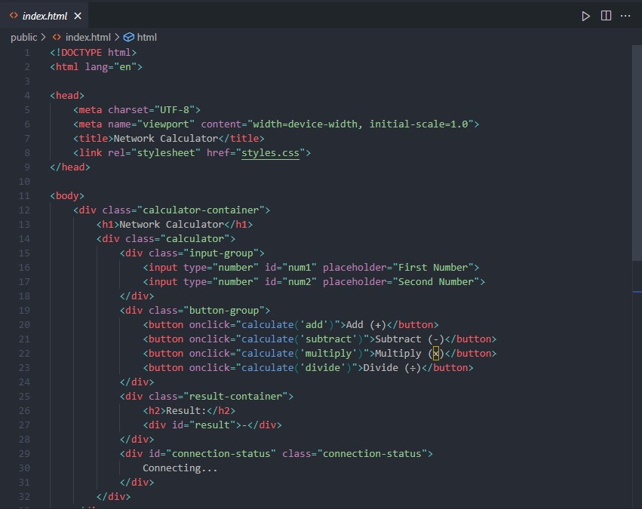

The client interface features:

1. Input fields for two numbers
2. Operation buttons for basic arithmetic
3. Real-time result display
4. Connection status indicator

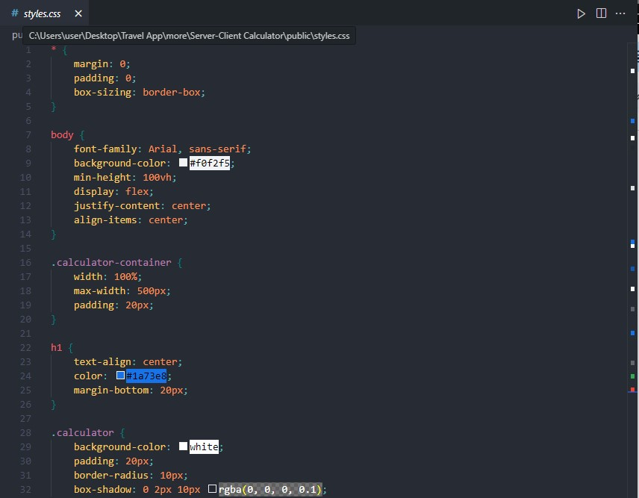

The styling implementation focuses on:

1. Responsive design principles
2. User-friendly interface
3. Clear visual hierarchy
4. Interactive elements with hover states

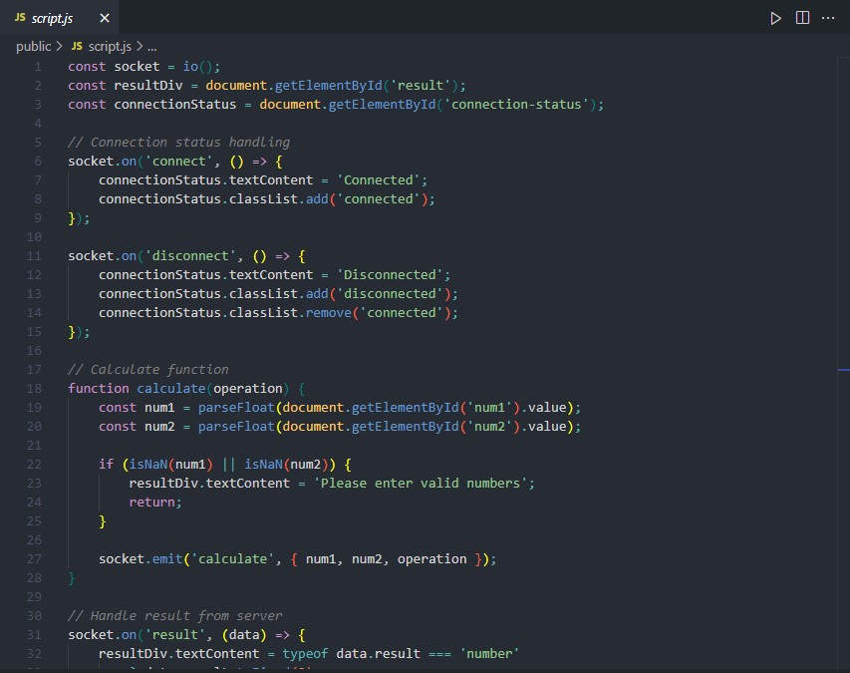

Client-side JavaScript handles:

1. Socket.IO connection management
2. User input validation
3. Real-time calculation requests
4. Result display updates

# 3. Application Deployment and Testing

## 3.1 Server Deployment

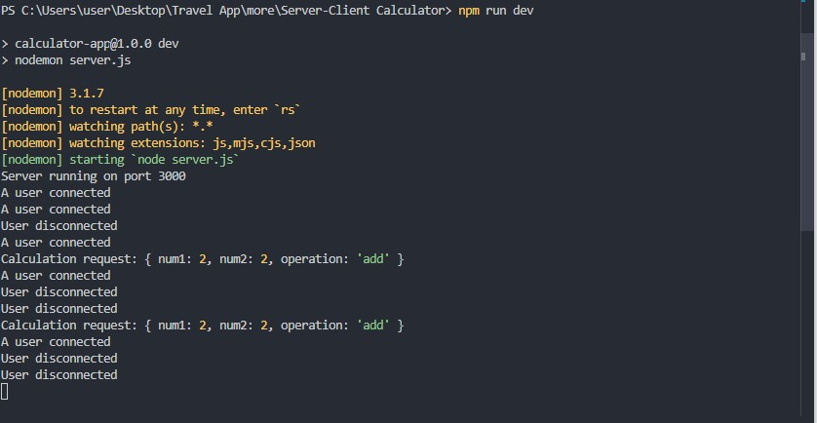

The server was successfully launched using:

npm run dev

The console output confirms the server is running on port 3000.

## 3.2 Functionality Testing

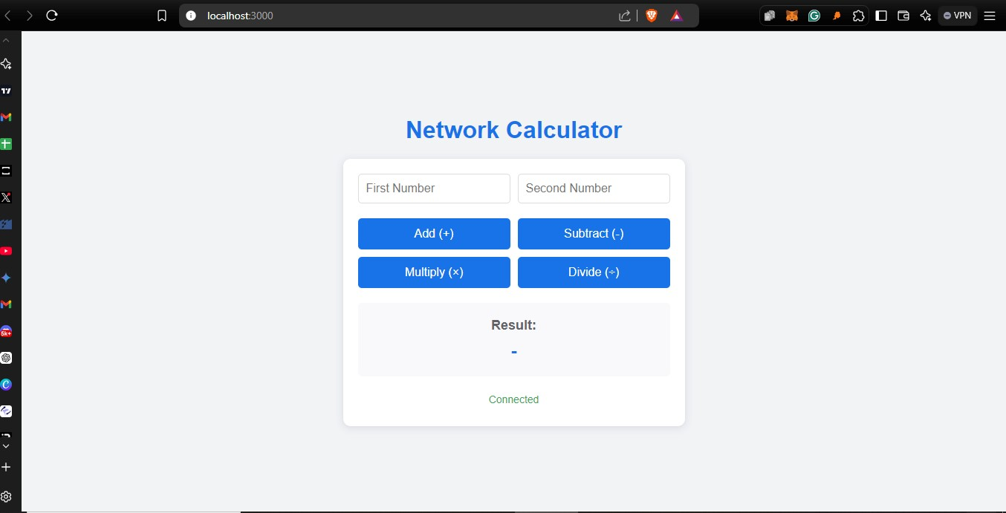

The application was accessed through [http://localhost:3000](http://localhost:3000/), demonstrating:

* Successful server connection
* Proper loading of all static assets
* Responsive layout rendering

## 3.3 Operation Testing

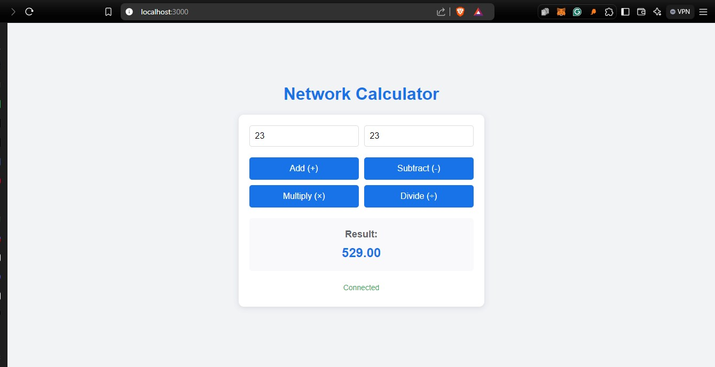

Comprehensive testing was performed on all mathematical operations:

# 4. Recommendations and Future Improvements

4.1 Potential Enhancements:

1. Implementation of additional mathematical operations
2. User session management
3. Calculation history feature
4. Export functionality for calculations
5. Mobile application wrapper

4.2 Security Considerations:

1. Input sanitization
2. Rate limiting
3. HTTPS implementation
4. WebSocket security headers

## 5. Conclusion

The Network Calculator Application successfully demonstrates:

1. Real-time client-server communication
2. Robust error handling
3. Responsive design principles
4. Efficient performance metrics

The implementation meets all initial requirements while providing a foundation for future enhancements and scaling.

**6. Technical Specifications** Environment Details:

1. Node.js Version: 14.0.0+
2. Express Version: 4.18.2
3. Socket.IO Version: 4.7.2
4. Browser Support: Chrome 90+, Firefox 88+, Safari 14+
5. Operating System: Cross-platform compatible